

**Spring boot project setup**

**And Dockerizing**

[www.yash.com](http://www.yash.com/)

 This document is exclusive property of Yash Technologies Pvt. Ltd.

No part or whole of this document may be reproduced in any form without written permission.

**Revision History**

|  |  |  |  |  |  |
| --- | --- | --- | --- | --- | --- |
| **Version** | **Date** | **Author** | **Reviewer** | **Approver** | **Change Summary** |
| 1.0 | 27-Nov-2018 | Kartik Jalgaonkar and  Isha Tiwari |  |  |  |
|  |  |  |  |  |  |
|  |  |  |  |  |  |
|  |  |  |  |  |  |

Pre-requisite to make your app running in Docker

1. Need to have spring boot application.
2. Go to start.spring.io page and create your spring boot application as per below screen shot.

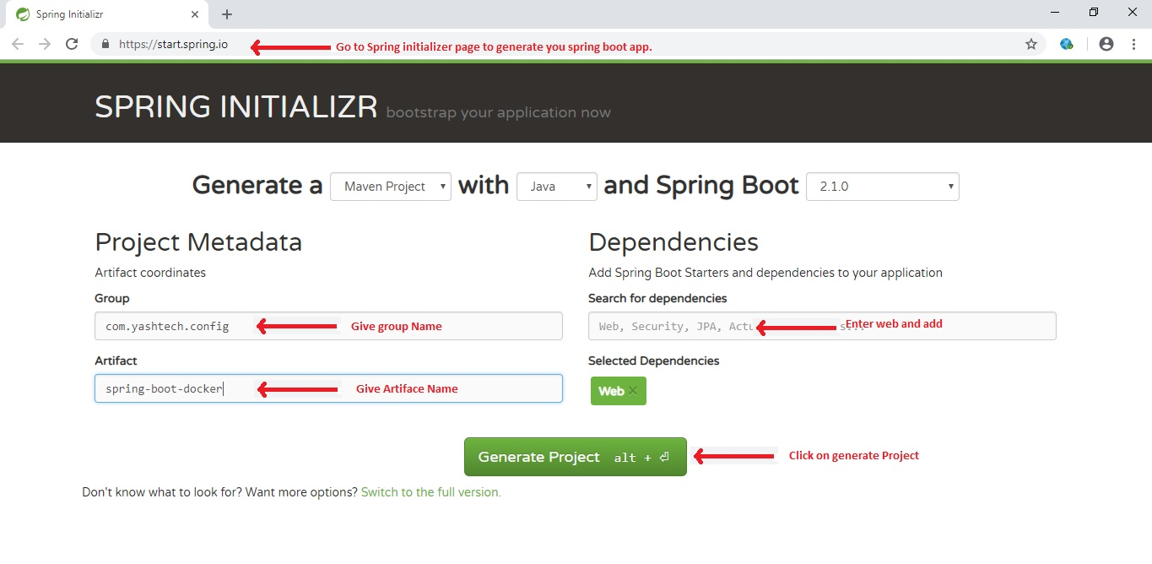

1. While you click on “Generate Project” the project will download in your system download location.
2. Now extract it and import in your STS IDE by “import maven project”.
3. The project now in your STS IDE and look like as below screen shot.

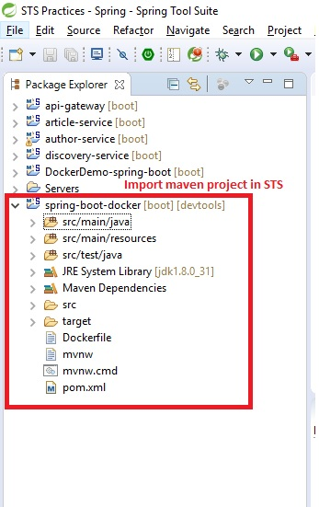

1. Now open main class and write below code as per screen shot.

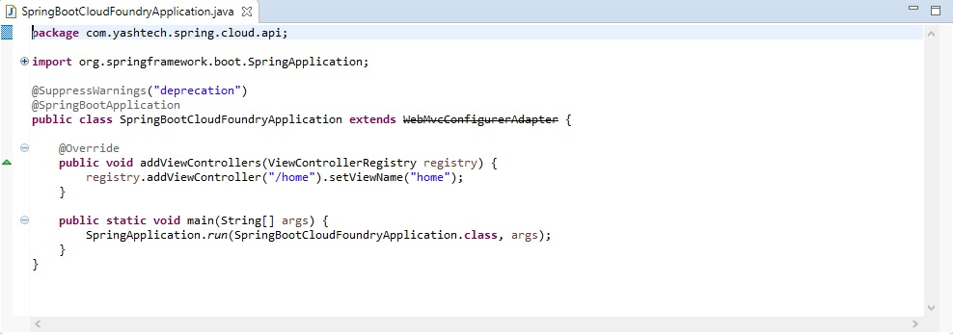

1. Add one more class in separate package as per below screen shot.

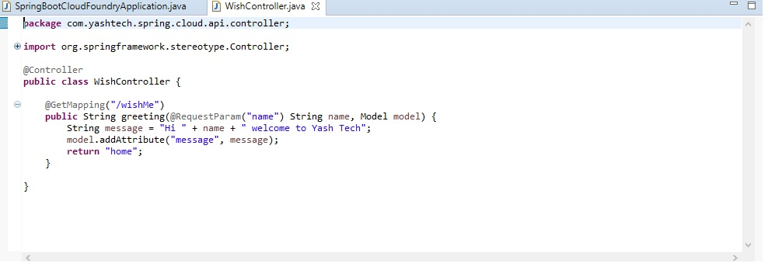

1. Add one tag in pom.xml file to change jar name as per below screen shot.

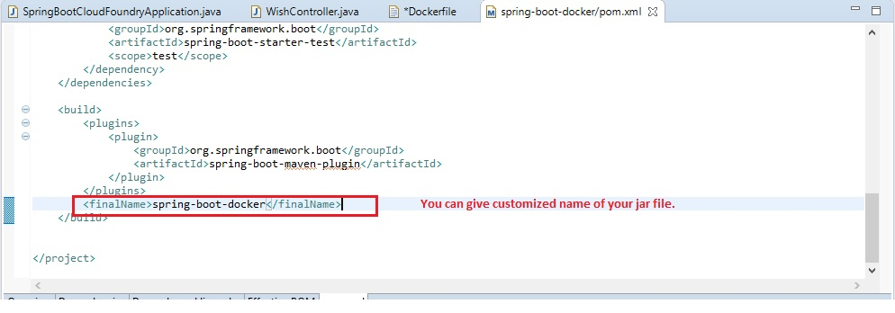

1. Now you need to create one file name as “Dockerfile” in project path and write below code in that file.

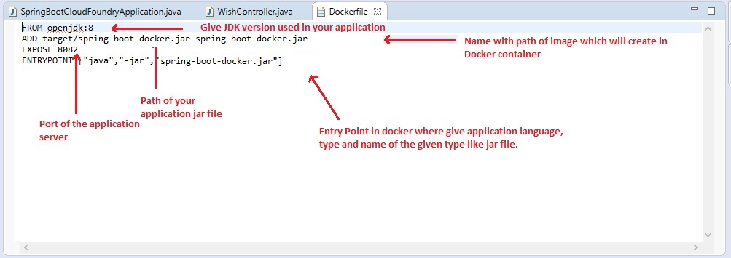

This file is basically used by docker to check application details to create image in docker container.

1. Create a jar file of application using maven install.

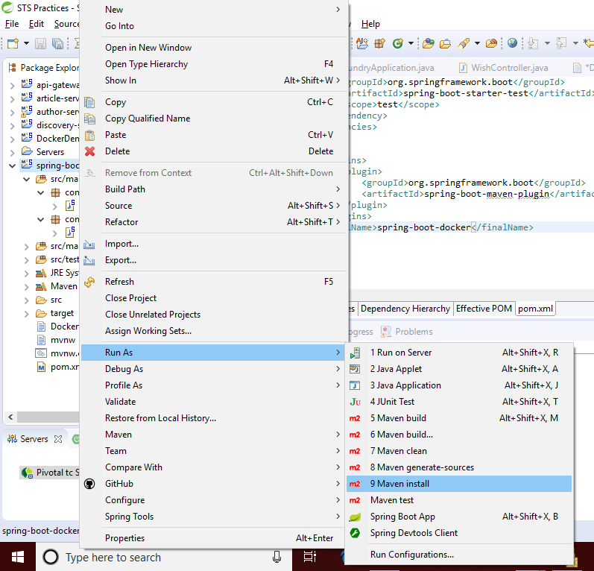

Setup of Docker and Steps for Single APP Deployment

1. Download Docker for Windows(Stable) using below link

[https://docs.docker.com/v17.09/docker-for-windows/install/#download-docker-for-windows](https://docs.docker.com/v17.09/docker-for-windows/install/" \l "download-docker-for-windows)

1. Sign up in docker website before installation.
2. After installing docker, it will open the popup window for login in docker.
3. After login in docker, it will show in running stage on task bar.
4. Now open a terminal window (Command Prompt or PowerShell, but not PowerShell ISE).
5. Run docker --version to ensure that you have a supported version of Docker:

> docker –version

Docker version 18.03.0-ce, build 0520e24

1. Open command prompt and go to project path.
2. Use below command to build and deploy the application:

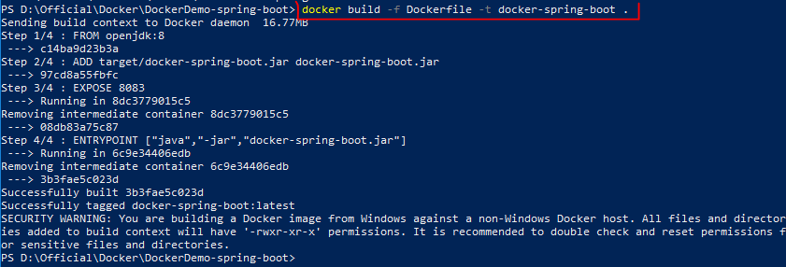

1. Use below command to run application:

**docker build -t <image_name> .**

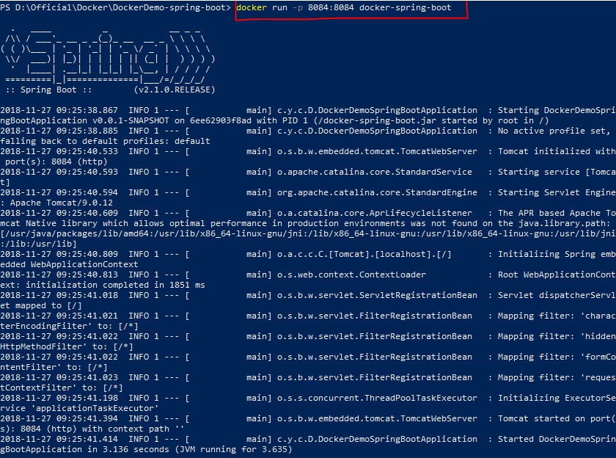

1. Now your application is up and running. You can check it on your browser using localhost:8084/url :-

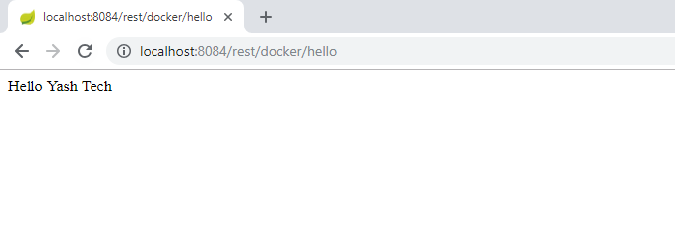

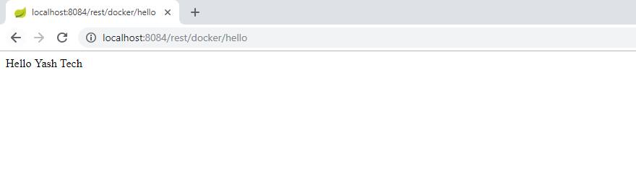 Setup of Docker and Steps for Multiple APP Deployment

1. You need to have multiple spring boot applications with individual Dockerfile. [**Please refer Single App Development process.]**
2. Create jar file for each application using maven install.
3. Create common docker-compose.yml file at your spring boot application path.

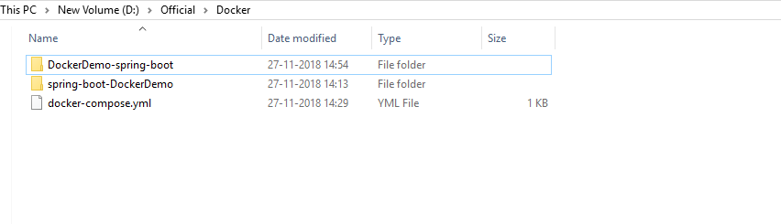

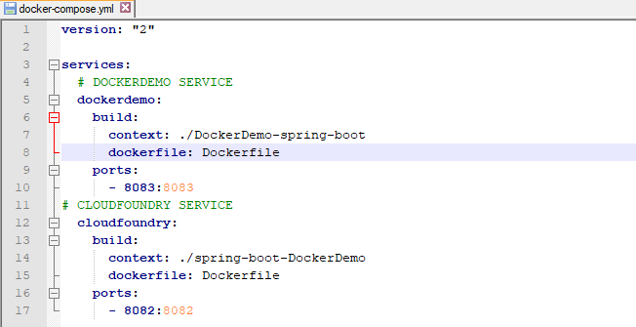

1. Open command prompt and go to directory where all applications are placed.
2. Use below commands to deploy applications.

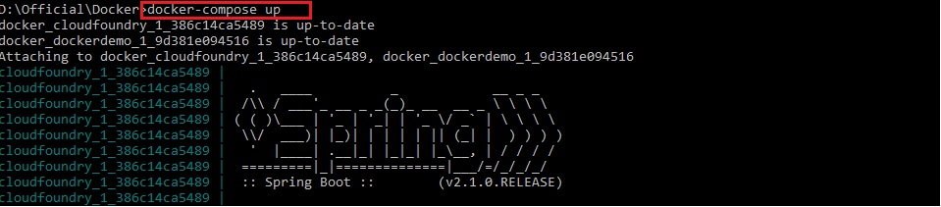

This command is to get details from docker-compose.yml file of your all

services details and then deploy it into docker container.

1. Now your application is up and running. You can check it on your browser using localhost:<port><URL>

